Question:

Why 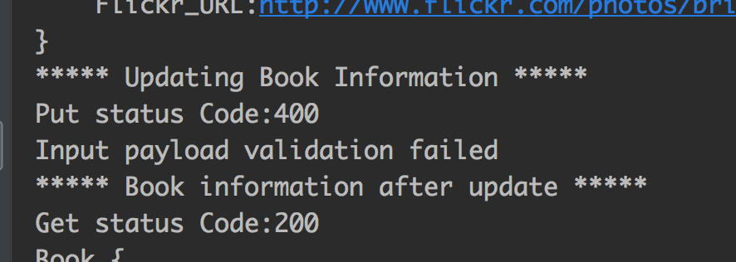

What mistake I make to be told Input payload validation failed.